DSA 0601 - Data handling and visualization
Set 5 - Website Analytics

Name : B.Jahnavi
Reg.no:192325043

1.Line Chart
Code:

library(ggplot2)
website <- data.frame(
Date = as.Date(c(
"2023-01-01",
"2023-01-02",
"2023-01-03",
"2023-01-04",
"2023-01-05"
)),
Page_Views = c( 1500,1600,1400,1650,1800),
Click_Through_Rate = c(2.3, 2.7, 2.0,2.4,2.6))
ggplot(
website,aes(x = Date, y = Page_Views)) +
geom_line( linewidth = 1) +
geom_point(size = 3) +
labs(
title = "Daily Website Page Views", x = "Date",y = "Page Views") +theme_minimal()

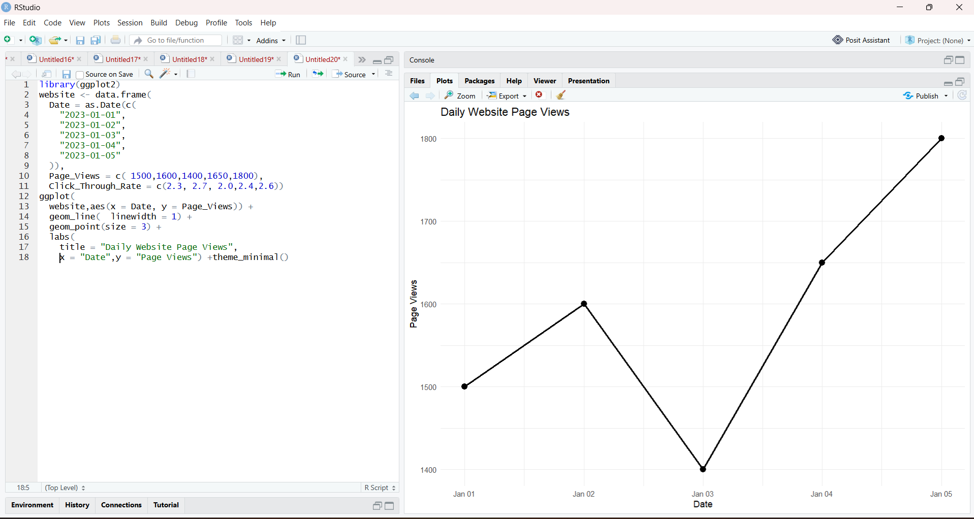

2.Bar Chart for Top N Click-through Rates
Code:
library(ggplot2)
library(dplyr)

# Create dataset
website <- data.frame(
Date = as.Date(c(
"2023-01-01",
"2023-01-02",
"2023-01-03",
"2023-01-04",
"2023-01-05"
)),
Page_Views = c(
1500,
1600,
1400,
1650,
1800
),
Click_Through_Rate = c(
2.3,
2.7,
2.0,
2.4,
2.6
)
)

# Set value of N
N <- 3

# Select top N days
top_days <- website %>%
arrange(desc(Click_Through_Rate)) %>%
slice_head(n = N)

# Create bar chart
ggplot(
top_days,
aes(
x = Date,
y = Click_Through_Rate
)
) +
geom_bar(
stat = "identity",
fill = "steelblue"
) +
geom_text(
aes(label = paste0(Click_Through_Rate, "%")),
vjust = -0.5
) +
labs(
title = paste("Top", N, "Days by Click-through Rate"),
x = "Date",
y = "Click-through Rate (%)"
) +
theme_minimal()

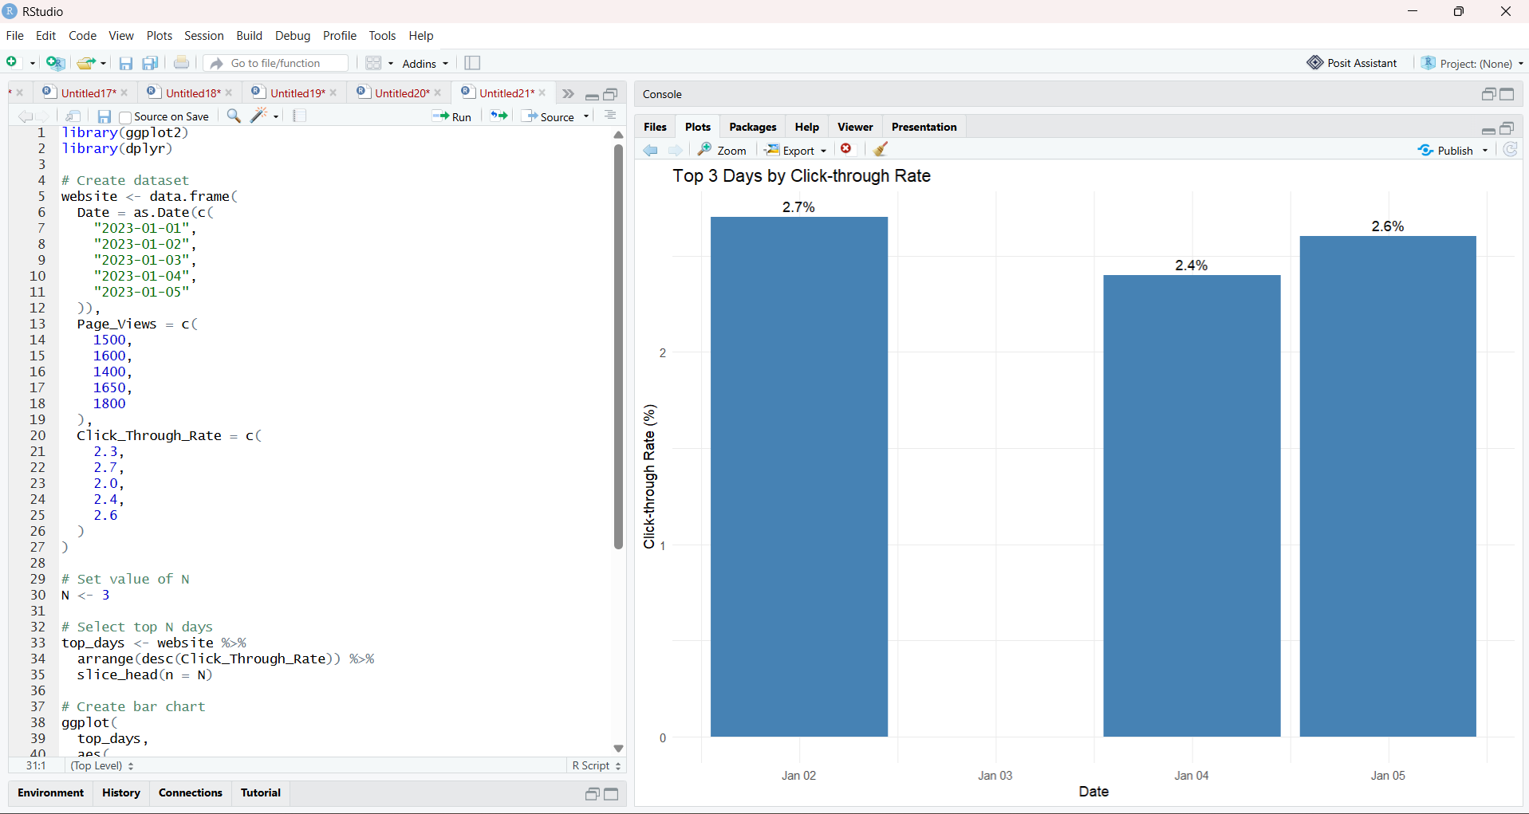

3.Stacked Area Chart for User Interactions
Code:
library(ggplot2)
library(tidyr)

# Enter your actual interaction data here
interactions <- data.frame(
Date = as.Date(c(
"2023-01-01",
"2023-01-02",
"2023-01-03",
"2023-01-04",
"2023-01-05"
)),
Likes = c(100, 120, 90, 130, 150),
Shares = c(40, 50, 35, 55, 60),
Comments = c(20, 25, 15, 30, 35)
)

# Convert to long format
interaction_long <- pivot_longer(
interactions,
cols = c(Likes, Shares, Comments),
names_to = "Interaction",
values_to = "Count"
)

# Create stacked area chart
ggplot(
interaction_long,
aes(
x = Date,
y = Count,
fill = Interaction
)
) +
geom_area() +
labs(
title = "Website User Interactions",
x = "Date",
y = "Number of Interactions",
fill = "Interaction Type"
) +
theme_minimal()

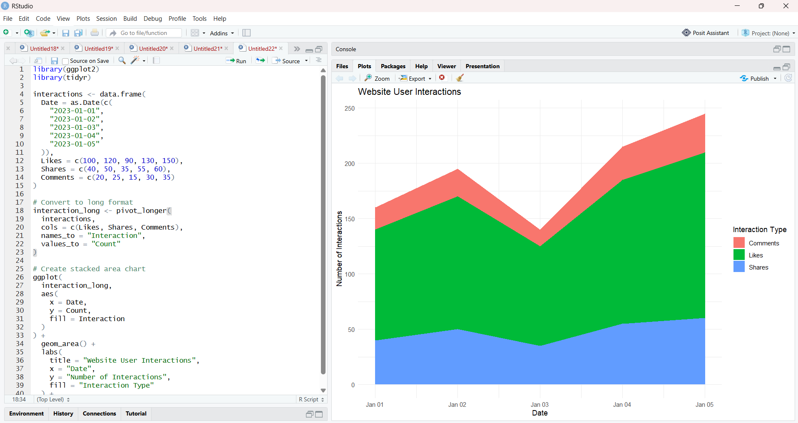

- Tableau Dashboard
Code:
website <- data.frame(
Date = as.Date(c(
"2023-01-01",
"2023-01-02",
"2023-01-03",
"2023-01-04",
"2023-01-05"
)),
Page_Views = c(
1500,
1600,
1400,
1650,
1800
),
Click_Through_Rate = c(
2.3,
2.7,
2.0,
2.4,
2.6
)
)

# Save data as CSV
write.csv(
website,
"Website_Traffic.csv",
row.names = FALSE
)

print("Website_Traffic.csv created successfully!")

